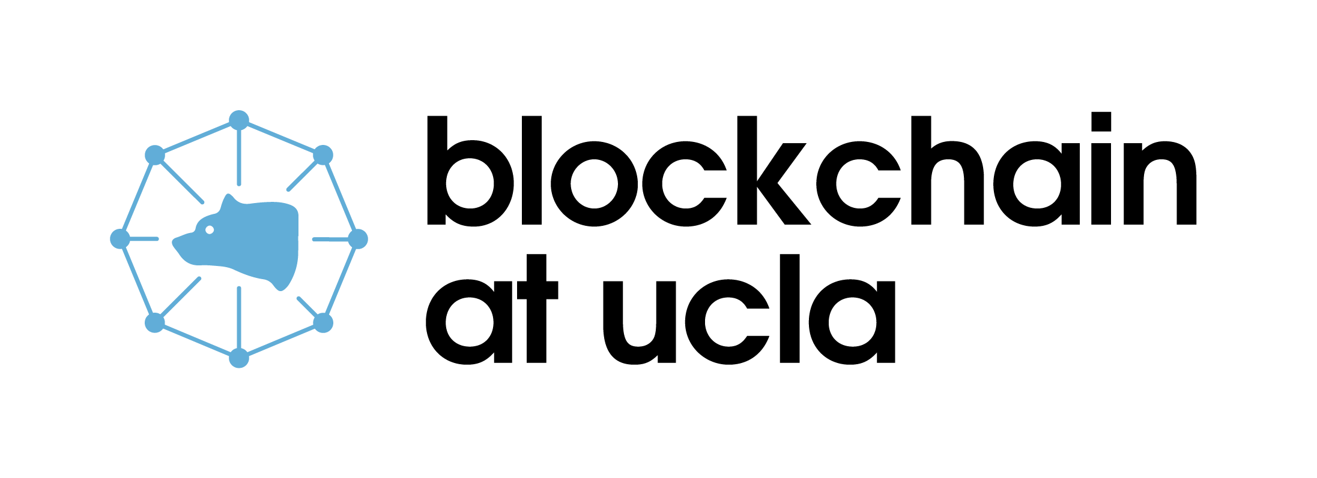

**A Brief Description:**

Blockchain at UCLA aims to enrich students’ knowledge on blockchain technology and help connect them to the industry.

**Mission:**

Blockchain at UCLA advances the eponymous technology within the UCLA academic community because we believe in its world-changing potential. Our student-led initiative provides the entire UCLA community—student and faculty, undergraduate and graduate—with opportunities for education, research, and community-building through lecture, analysis, and experiential learning. We exist to advance access to blockchain knowledge, the stature of the university in the field, and the frontier of the field itself.

**About:**

You don’t need any prior experience or knowledge of blockchain to be a part of Blockchain at UCLA! Our aim is to create an environment where students of all domains can share information about the field and discuss different areas of blockchain. Beginners will have access to resources to better their understanding of both technical and non-technical concepts. Those with more blockchain experience will have opportunities to connect with the industry and continue their learning.

We will be linking with Blockchain Acceleration Foundation (BAF) to provide weekly virtual events where students can learn from and network with industry leaders and professionals. The club itself will also host blockchain education lectures and technical workshops in the future, and also has a Projects Team which involves building applications using blockchain technology.

Interested and want to learn more about the club? Join our virtual ***Fall General Meeting on Oct. 8th at 6:30 P.M***. via Zoom!

*\*\*\*(ID to join the Zoom meeting will be posted near the date on our Discord and Facebook)*

Join our Discord server and add us on Facebook for club updates!

**Discord:** [**discord.gg/XjjuevH**](https://discord.gg/XjjuevH)

**Facebook:** [**www.facebook.com/blockchainucla**](https://www.facebook.com/blockchainucla)

**Email:** [**info@blockchainatucla.com**](mailto:info@blockchainatucla.com)

**Website:** [**https://www.blockchainatucla.com**](https://www.blockchainatucla.com)